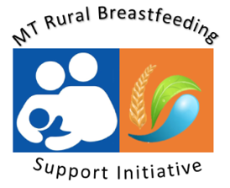
Overview

To increase breastfeeding support for rural Montana communities, the Nutrition & Physical Activity Program, in partnership with the Montana Hospital Association, is providing scholarships ($825) for Critical Access Hospital staff to complete the online Certified Lactation Counselor Training (CLC). This 92-hour self-paced online course includes practical skills, theoretical foundations & competency verification. Application Deadline December 1st, 2025.

Applicant Information
Name: |  | Street Address:  (City & Postal Code)
Telephone: |  | EMAIL:
Critical Access Hospital Employer: |  | Supervisor Contact  (to verify employment).

This CLC scholarship covers registration, exam, and textbook ($825) for a MT Critical Access Hospital staff to complete the online Certified Lactation Counselor Training (CLC). Training must be completed by June 1, 2026

Requirements
- Full time Montana resident; and
- Employed in perinatal healthcare at a MT Critical Access Hospital; (travel nurse, temporary hire, or locum tenens applicants will not be considered for scholarships); and
- Must complete the online training and examination by June 1, 2026

Please Respond Please thoroughly describe your current role at your facility & how completion of the online Certified Lactation Counselor Training will: 1) Support lactation work at your hospital & community, & 2) support your professional goals in lactation support. Scoring is based on an an in-depth response to the above questions.

Please forward completed application to TMiller6@mt.gov by December 1st, 2025.
These scholarships are provided through the Medicare Rural Hospital Flexibility Program, an HRSA funded program with support from the Montana Department of Public Health and Human Services.

